Knockout mouse models: https://getargeting-2026.vercel.app/knockout-mouse-models

- I think it’s cool to include a visual of the type of knockout, but think this is too complex and suggests the use of ES cells to achieve this because of the selection cassette and so I would want to keep it simpler. Let’s discuss:
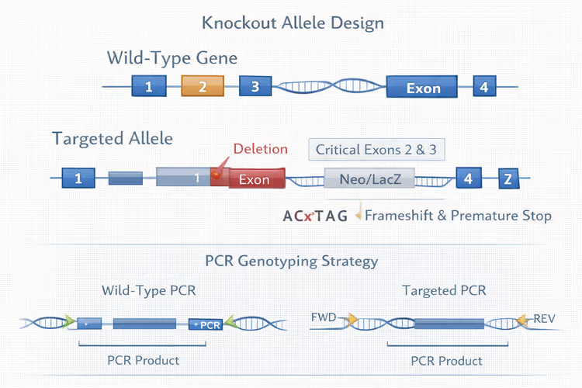

- Can you include an “and” between nature, and cell:
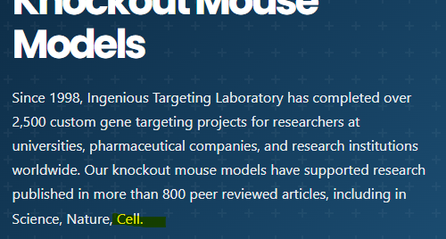

- Is the second paragraph supposed to be a smaller text size than the first paragraph?:

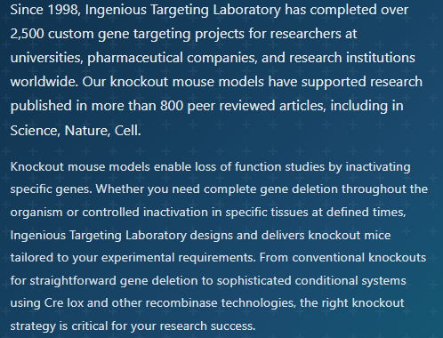

- Can you capitalize the “l” in LoxP here:
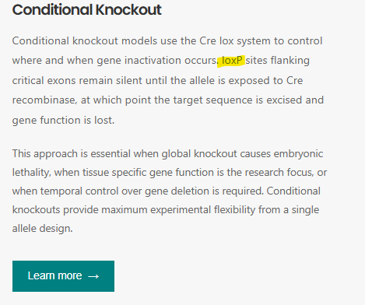

- Again I think it’s cool to include these images, but this one isn’t correct (ie, there are two yes’s coming off of the first question. Also, unless we can click to make it bigger, it’s grainy and hard to read:
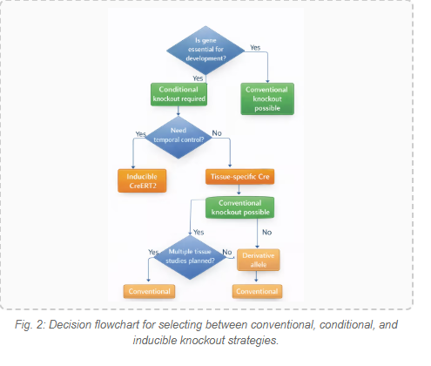
- For the selected publications, can we change the format across the site so that the article title is in a different color than the rest? Also, it looks like it’s supposed to be click-able but when I clicked, nothing happened:
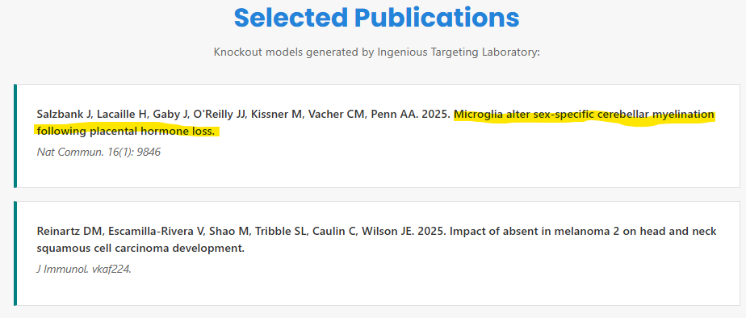

- In the glossary of terms, can we not have ES cells be one of them/choose something else?:
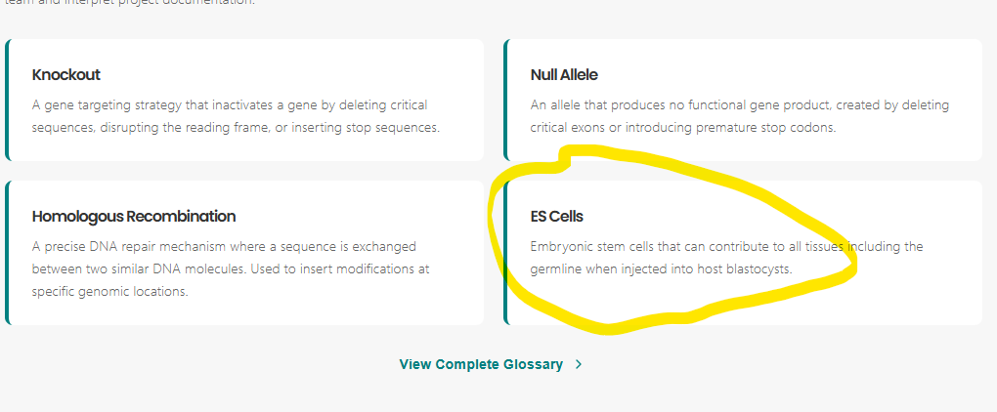

- In the resources section, there are some things I noticed: 1) The first resource (conditional KO comparison chart), we call our technology “No Doubt” which is the old name for this technology. The new name is “TruView Conditional Knockout”. Can this be changed and re-uploaded? Can we also add some context to the top like “Here are some types of conditional knockouts that ingenious can create” or something like that? For the next two resources (cKO quick guide and Cre-lox design guide), they link to old hubspot download pages. We paywalled these to collect researchers' emails in order to access. I still would like this feature but let’s discuss if the way it is working now is OK. Finally, the last resource (breeding scheme architect) needs to be vetted by our breeding people for accuracy before we can bring people to this:
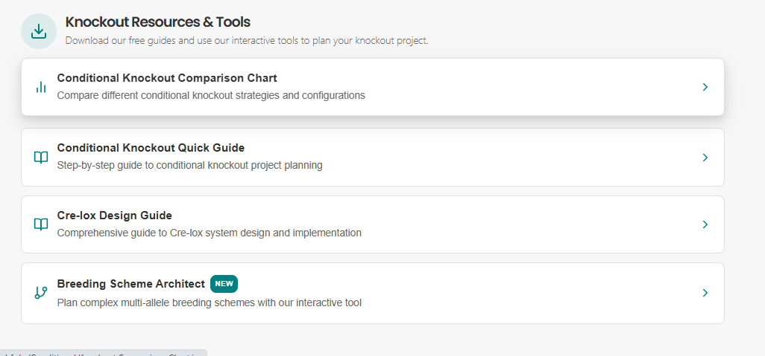

- This description has to change. I would just take out “CRISPR vs ES cell targeting comparisons completely. As I have said before, we may need something more catchy in general because most people won’t care about anything related to knockout mouse generation only:


- We may want to remove all timeline mention across the site, unless you feel it’s really important to keep. If we will keep it, we should just confirm with Paul that this is OK:
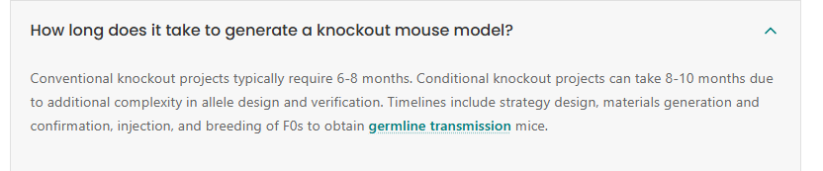

- Is it possible to remove the ES cell link as well as the page it links to? I’m not sure how important it is to keep a page dedicated to ES cells. I think we meant to delete this. Also, the last two resources go to 404 error pages:
